* Supervised machine learning model.
* Can be used for both classification (SVC) and regression (SVR).

**SVM as a Classifier (SVC):**

* Discriminative and non-probabilistic classifier.
* It classifies the different groups by finding the decision boundary that best separates the groups based on their known categories.
* This best decision boundary is the one that maximizes the margins between any two groups. (**Maximum Margin Classifier)**.

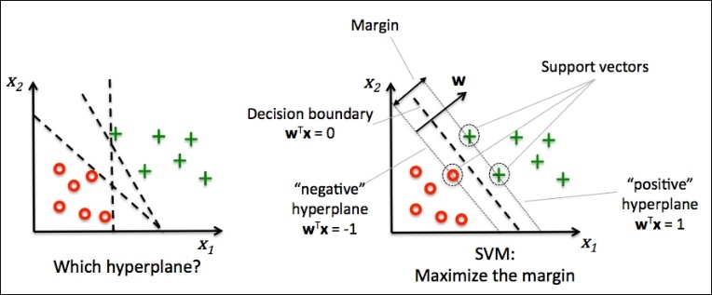 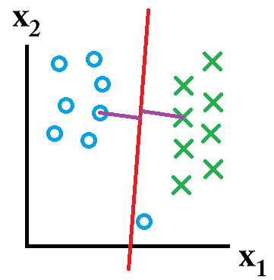

Fig.1 Maximum Margin Classifier and Support Vectors in SVM Fig.2 Outlier ignored in general SVM

* Linearly Separable Dataset 🡪 Simple
* Non-Linearly Separable Dataset 🡪 Not so simple (**kernel trick** used)

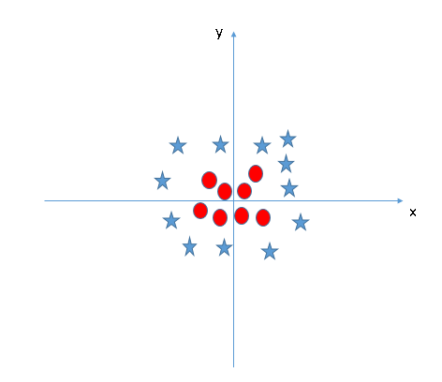 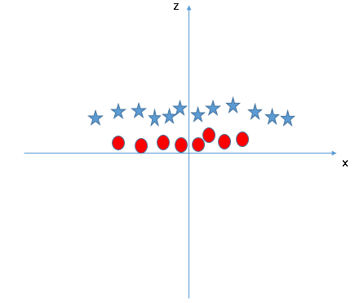

Fig 3. Non-linearly separable data Fig 4. Mapping into higher dimension (adding z-axis component)

Z = x^2 + y^2

* SVM does not need the actual vectors to work on it, it can do it only with the **dot products** between them. This dot product is called a **kernel function**.

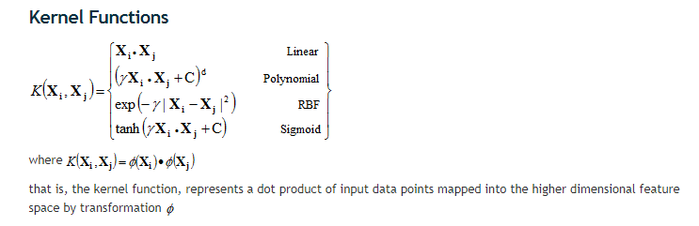

Fig 5. Different types of Kernel functions

Sources:

Fig 1: <https://www.packtpub.com/graphics/9781783555130/graphics/3547_03_07.jpg>

Fig 2: <https://stackoverflow.com>

Fig 3: <https://www.analyticsvidhya.com/wp-content/uploads/2015/10/SVM_8.png>

Fig 4: <https://www.analyticsvidhya.com/wp-content/uploads/2015/10/SVM_9.png>

Fig 5: <http://www.statsoft.com/textbook/support-vector-machines>